ЕГЭ. SPEAKING Task 3. NEW.
A model with a sample answer:
You are going to give an interview. You have to answer 5 questions. Give full answers to the questions (2-4 sentences). Remember you have 40 seconds to answer each question.
Electronic assistant: Hello! It’s the electronic assistant. We kindly ask you to take part in our survey. We need to find out how people feel about earning money in our region. Please answer our questions. So, let’s get started.

- Electronic assistant: How do you get your pocket money?
Student: As a rule, my parents pay me for some work they want me to do. Sometimes my father needs some help with documents at the company he runs. Occassionally, I help our neighbors at our dacha and they pay me. I also help one company to fill in their web site with different content information.

- Electronic assistant: What do you spend your pocket money on?
Student: Mainly, I spend my pocket money on different things that my parents consider useless. Like, if I want to upgrade my computer to a more powerful version, I pay for it. If I want to buy the newest telephone, I have to pay myself. My parents call it capricious, but I call it trendy.

- Electronic assistant: Are you good with the money you have? Can you save the money?
Student: Well, I guess I am not very good with the money I get because I can spend it on some useless things and entertainments but I try to be wiser and to save some money in order to buy what I really need.
- Electronic assistant: Would you like to take a part time job? Why?
Student: Actually, I love part time jobs and I’ve been taking them for more than 5 years. I call it "freelance job". I dedicate to this job a part of my time. I think that having a part time job makes a teen independent and teaches him to deal with money, plan his budget, and save money for something important.

- Electronic assistant: What part job would you recommend to any teenager who wants to earn some extra money during their summer holiday?
Student: I think I would recommend to a teen who wants to make some extra money to work as a deliveryman, or a waiter. Those who understand computers could also make good content managers. You have to just upload some information to web-sites. He can also clean dishes at a restaurant. One of my friends had such a job and was quite satisfied.

This is the end of the survey. Thank you very much for your time.
- You are going to give an interview. You have to answer 5 questions. Give full answers to the questions (2-4 sentences). Remember you have 40 seconds to answer each question.
Electronic assistant: Hello! It’s the electronic assistant of the Dolphin Sports Club. We kindly ask you to take part in our survey. We need to find out how people feel about doing sports in our region. Please answer five questions. The survey is anonymous – you don’t have to give your name. So, let’s get started.
- How many times a week do you do sports?
- What sport is the most popular with teenagers in your region?
- What sports facilities are available in the place where you live?
- Why do you think it is important to keep fit?
- What would you advise a person who wants to keep fit?

- You are going to give an interview. You have to answer 5 questions. Give full answers to the questions (2-4 sentences). Remember you have 40 seconds to answer each question.

Electronic assistant: Hello! This is the electronic assistant of the Club “Help me”. We kindly ask you to take part in our survey. We need to find out what teenagers think about their school subjects. Please answer our five questions. So, let’s get started.

- What subjects do you study at school?
- What’s your favorite subject? Explain why.
- What subjects are more important: theoretical or practical? Why?
- How much time do you spend on your school tasks?
- What tasks do you avoid doing? Why?

- You are going to give an interview. You have to answer 5 questions. Give full answers to the questions (2-4 sentences). Remember you have 40 seconds to answer each question.

Electronic assistant: Hello! This is the electronic assistant of the Young Journalists’ Club. We kindly ask you to take part in our survey. We need to find out what teenagers think about mass media. Please answer our questions. So, let’s get started.

- What kinds of mass media can you name?
- How often do you watch TV? Why?
- Are any magazines or newspapers popular with your classmates? Why?
- What kinds of mass media can’t you do without?
- What in your opinion makes the Internet the most wide-spread kind of mass media?

- You are going to give an interview. You have to answer 5 questions. Give full answers to the questions (2-4 sentences). Remember you have 40 seconds to answer each question.
Electronic assistant: Hello! This is the electronic assistant of the Internet Club. We kindly ask you to take part in our survey. We need to find out what teenagers think about the Internet. Please answer our questions. So, let’s get started.
- How much time do you spend on the Internet daily?
- Can you do without the Internet? Explain why.
- What’s better for you: to make friends via the Internet or in real life? Why?
- Why do many people prefer Internet to TV in your opinion?
- In what way would you recommend your friend to use the Internet?

- You are going to give an interview. You have to answer 5 questions. Give full answers to the questions (2-4 sentences). Remember you have 40 seconds to answer each question.
Electronic assistant: Hello! This is the electronic assistant of the Club “E-learning”. We kindly ask you to take part in our survey. We need to find out what teenagers think about the distance education. Please answer our questions. So, let’s get started.
- Do you find your school Information Technology Classes interesting? Why?
- How much time per day do you spend on online studying?
- What benefits does distance education have?
- In what way can distance learning be harmful?
- Are you for or against distance learning? Why do you think so?

- You are going to give an interview. You have to answer 5 questions. Give full answers to the questions (2-4 sentences). Remember you have 40 seconds to answer each question.
Electronic assistant: Hello! It’s the electronic assistant of the Easy Learning Language School. We kindly ask you to take part in our survey. We need to find out how people feel about learning foreign languages. Please answer our questions.
- Is it difficult or easy for you to learn a foreign language and why?
- How many times a week do you study a foreign language?
- Why do people learn foreign languages?
- Would you like to take part in any exchange programmes and why?
- What would you advise a person who wants to learn a foreign language?

- You are going to give an interview (on the topic daily timetable). You have to answer 5 questions. Give full answers to the questions (2-4 sentences). Remember you have 40 seconds to answer each question.
Electronic assistant: Hello! It’s the electronic assistant of the International E-Library. We kindly ask you to take part in our survey. We need to find out how people feel about reading. Please answer our questions. So, let’s get started.
- How much time a week do you spend on reading?
- Is it popular among teenagers to read books nowadays?
- Where do you usually get books and why?
- Why do you think it is important to read books?
- What books do you prefer: electronic or printed and why?
8. You are going to give an interview. You have to answer 5 questions. Give full answers to the questions (2-4 sentences). Remember you have 40 seconds to answer each question.
Electronic assistant: Hello! It’s the electronic assistant of the Independent Channel One. We kindly ask you to take part in our survey. We need to find out how people feel about watching TV in our region. Please answer six questions. So, let’s get started.
- How many times a week do you watch TV?
- What programmes are most popular with teenagers in your region?
- What kinds of programmes do you want to have on our channel? Why?
- Why do people watch TV?
- What do you think about commercials/ advertisements on TV?
9. You are going to give an interview. You have to answer 5 questions. Give full answers to the questions (2-4 sentences). Remember you have 40 seconds to answer each question.
Electronic assistant: Hello! It’s the electronic assistant of the Hobby Centre. We kindly ask you to take part in our survey. We need to find out how people feel about taking up hobbies in your region. Please answer our questions. So, let’s get started.
- What is your hobby and why are you interested in this particular thing?
- How much time a week do you spend on your hobby?
- What hobbies are the most popular with teenagers nowadays?
- Why do you think people take up hobbies?
- What would you advise a person who wants to start the hobby as you have?
10. You are going to give an interview. You have to answer 5 questions. Give full answers to the questions (2-4 sentences). Remember you have 40 seconds to answer each question.
Electronic assistant: Hello! It’s the electronic assistant of the Open Music Club. We kindly ask you to take part in our survey. We need to find out how people feel about music. Please answer six questions. So, let’s get started.
- How often do you listen to music?
- What music is the most popular with teenagers nowadays?
- Do you have any favourite singers/musicians/groups at the moment and which ones?
- Why do you think people like music?
- Are there any musical instruments that you would like to learn?
11. You are going to give an interview. You have to answer 5 questions. Give full answers to the questions (2-4 sentences). Remember you have 40 seconds to answer each question.
Electronic assistant: Hello! It’s the electronic assistant of the New Drama School. We kindly ask you to take part in our survey. We need to find out how people feel about theatre. Please answer our questions. So, let’s get started.
- How often do you go to the theatre and do you like it?
- Is it popular among teenagers to go to the theatre in your region?
- Do you have any theatres in the place where you live?
- Why do you think people like going to the theatre?
- Would you like to take part in some theatrical performance? Which one?
12. You are going to give an interview. You have to answer 5 questions. Give full answers to the questions (2-4 sentences). Remember you have 40 seconds to answer each question.
Electronic assistant: Hello! It’s the electronic assistant of the Rainbow Shopping Mall. We kindly ask you to take part in our survey. We need to find out how people feel about shopping. Please answer our questions. So, let’s get started.
- How many times a week do you do the shopping?
- What do teenagers usually buy while shopping?
- What facilities in shopping malls are available in the place where you live?
- When was the last time you really enjoyed going shopping and what did you buy?
- Have you ever had any bad experiences while shopping?
13. You are going to give an interview. You have to answer 5 questions. Give full answers to the questions (2-4 sentences). Remember you have 40 seconds to answer each question.
Electronic assistant: Hello! It’s the electronic assistant of the Travel Agency. We kindly ask you to take part in our survey. We need to find out how people feel about travelling. Please answer our questions. So, let’s get started.
- Have you ever travelled? If yes, where and when?
- Why do people go travelling?
- What ways of travelling are the most popular in your country?
- What way of travelling would you prefer and why?
- What travel problems might travelers have while going abroad?
14. You are going to give an interview. You have to answer 5 questions. Give full answers to the questions (2-4 sentences). Remember you have 40 seconds to answer each question.
Electronic assistant: Hello! It’s the electronic assistant of the Exam Center. We kindly ask you to take part in our survey. We need to find out how people feel about taking exams. Please answer our questions. So, let’s get started.
- How do you usually feel before you have to do an exam?
- What exams do you prefer: oral or written? Why?
- How do you prepare for your English exams?
- Are exams useful from your point of view? Why do you think so?
- What would you recommend to a student who has failed his or her exam?

15. You are going to give an interview. You have to answer 5 questions. Give full answers to the questions (2-4 sentences). Remember you have 40 seconds to answer each question.
Electronic assistant: Hello! It’s the electronic assistant. We kindly ask you to take part in our survey. We need to find out how people feel about using mobile phones. Please answer our questions. So, let’s get started.
- What do you use your mobile phone for?
- What other features of mobile phones do you find useful?
- In what public places do you normally turn off the sound of your mobile phone?
- What would you miss most if you had to do without your mobile phone for a week?
- How do people use a mobile phone to improve their foreign language skills?

16. You are going to give an interview. You have to answer 5 questions. Give full answers to the questions (2-4 sentences). Remember you have 40 seconds to answer each question.
Electronic assistant: Hello! It’s the electronic assistant. We kindly ask you to take part in our survey. We need to find out how people feel about eating habits. Please answer our questions. So, let’s get started.
- What kind of food do you prefer to eat?
- How are the eating habits now in your country different from eating habits in the past?
- How healthy is your country’s food?
- Why do you think different cultures have different table manners?
- How may eating habits change in coming decades?

17. You are going to give an interview. You have to answer 5 questions. Give full answers to the questions (2-4 sentences). Remember you have 40 seconds to answer each question.
Electronic assistant: Hello! It’s the electronic assistant. We kindly ask you to take part in our survey. We need to find out how people feel about health. Please answer our questions. So, let’s get started.
- In what ways do you try to stay healthy?
- Is it easy to keep fit where you live?
- What do you think is more important, eating healthily or doing exercise?
- Have you ever had any habits which you consider to be unhealthy?
- How can children be encouraged to adopt healthy habits?

18. You are going to give an interview. You have to answer 5 questions. Give full answers to the questions (2-4 sentences). Remember you have 40 seconds to answer each question.
Electronic assistant: Hello! It’s the electronic assistant. We kindly ask you to take part in our survey. We need to find out how people feel about English study. Please answer our questions. So, let’s get started.
- When did you start learning English?
- Do you think it’s important for children to learn English?
- Do you enjoy learning English?
- What activity do you find most useful for learning English?
- What do you find most difficult about learning English?

19. You are going to give an interview. You have to answer 5 questions. Give full answers to the questions (2-4 sentences). Remember you have 40 seconds to answer each question.
Electronic assistant: Hello! It’s the electronic assistant. We kindly ask you to take part in our survey. We need to find out how people feel about Weather and Climate. Please answer our questions. So, let’s get started.
- What is the climate like in your country?
- Are there any problems with the climate in your country?
- What is your favourite type of weather?
- What kind of weather do you dislike?
- Would you prefer to live in a hot or cold country?
- What is the best/worst weather for travelling in?

20. You are going to give an interview. You have to answer 5 questions. Give full answers to the questions (2-4 sentences). Remember you have 40 seconds to answer each question.
Electronic assistant: Hello! It’s the electronic assistant. We kindly ask you to take part in our survey. We need to find out how people feel about leisure activities. Please answer our questions. So, let’s get started.
- How much free time do you have per week?
- How do you like to relax at the end of the day?
- What kinds of things do you enjoy doing at the weekends?
- Do you have any plans for next weekend?
- What would you do if you had more free time?

ЕГЭ. Speaking. Task 4. NEW.
1. Imagine that you’re doing a project “Life without gadgets” together with your friend. You have found some illustrations and want to share the news. Leave a voice message to your friend. In 2.5 minutes be ready to tell the friend about the photos:
- Give a brief description of the photos (2 features connected with the subject of the project in each photo minimum);
- Say in what way the pictures are different (2 features connected with the subject of the project minimum);
- Mention the advantages and disadvantages (1-2) of the two types of books;
- Explain how these photos illustrate the project “Life without gadgets”
- Express your opinion on the subject of the project – whether you would like to live without gadgets and why yes or no.





2. Imagine that you’re doing a project “Life in the city vs life in the country” together with your friend. You have found some illustrations and want to share the news. Leave a voice message to your friend. In 2.5 minutes be ready to tell the friend about the photos:
- Give a brief description of the photos (2 features connected with the subject of the project in each photo minimum);
- Say in what way the pictures are different (2 features connected with the subject of the project minimum);
- Mention the advantages and disadvantages (1-2) of the two types of life;
- Explain how these photos illustrate the project;
- Express your opinion on the subject of the project – whether you would like to live in the city or in the country and why.


3. Imagine that you’re doing a project “Free Time Activities for Teens” together with your friend. You have found some illustrations and want to share the news. Leave a voice message to your friend. In 2.5 minutes be ready to tell the friend about the photos:
- Give a brief description of the photos (2 features connected with the subject of the project in each photo minimum);
- Say in what way the pictures are different (2 features connected with the subject of the project minimum);
- Mention the advantages and disadvantages (1-2) of the two types of activities;
- Explain how these photos illustrate the project;
- Express your opinion on the subject of the project – whether you would like to go climbing or dancing and why.



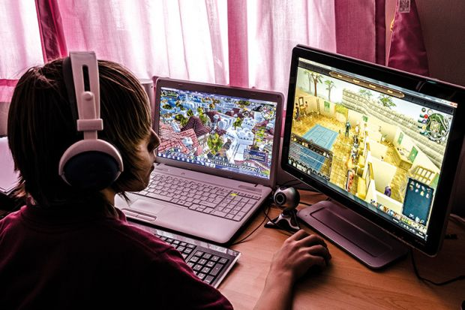

4. Imagine that you’re doing a project “Ways of travelling” together with your friend. You have found some illustrations and want to share the news. Leave a voice message to your friend. In 2.5 minutes be ready to tell the friend about the photos:
- Give a brief description of the photos (2 features connected with the subject of the project in each photo minimum);
- Say in what way the pictures are different (2 features connected with the subject of the project minimum);
- Mention the advantages and disadvantages (1-2) of the two ways of travelling;
- Explain how these photos illustrate the project;
- Express your opinion on the subject of the project – whether you would prefer to travel by plane or by train and why.


5. Imagine that you’re doing a project “Big Families vs Small Families” together with your friend. You have found some illustrations and want to share the news. Leave a voice message to your friend. In 2.5 minutes be ready to tell the friend about the photos:
- Give a brief description of the photos (2 features connected with the subject of the project in each photo minimum);
- Say in what way the pictures are different (2 features connected with the subject of the project minimum);
- Mention the advantages and disadvantages (1-2) of the two types of families;
- Explain how these photos illustrate the project;
- Express your opinion on the subject of the project – whether you would like to be brought up in a big or a small family and why.




6. Imagine that you’re doing a project “Sports Activities” together with your friend. You have found some illustrations and want to share the news. Leave a voice message to your friend. In 2.5 minutes be ready to tell the friend about the photos:
- Give a brief description of the photos (2 features connected with the subject of the project in each photo minimum);
- Say in what way the pictures are different (2 features connected with the subject of the project minimum);
- Mention the advantages and disadvantages (1-2) of the two types of sports activities;
- Explain how these photos illustrate the project;
- Express your opinion on the subject of the project – whether you would prefer to go swimming or skating and why.
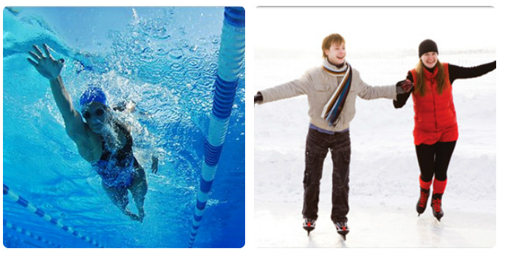

7. Imagine that you’re doing a project “Jobs” together with your friend. You have found some illustrations and want to share the news. Leave a voice message to your friend. In 2.5 minutes be ready to tell the friend about the photos:

- Give a brief description of the photos (2 features connected with the subject of the project in each photo minimum);
- Say in what way the pictures are different (2 features connected with the subject of the project minimum);
- Mention the advantages and disadvantages (1-2) of the two types of work;
- Explain how these photos illustrate the project;
- Express your opinion on the subject of the project – whether you would like to do such jobs and why.

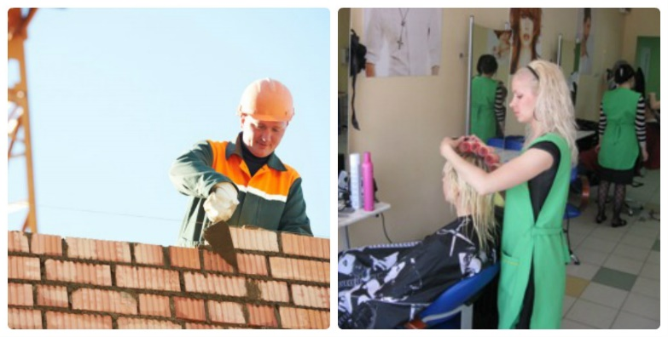

8. Imagine that you’re doing a project “Watching Films” together with your friend. You have found some illustrations and want to share the news. Leave a voice message to your friend. In 2.5 minutes be ready to tell the friend about the photos:

- Give a brief description of the photos (2 features connected with the subject of the project in each photo minimum);
- Say in what way the pictures are different (2 features connected with the subject of the project minimum);
- Mention the advantages and disadvantages (1-2) of the two ways of watching films;
- Explain how these photos illustrate the project;
- Express your opinion on the subject of the project – whether you would prefer to watch a film at home or in the cinema and why.





9. Imagine that you’re doing a project “Visiting Moscow and London on Holidays” together with your friend. You have found some illustrations and want to share the news. Leave a voice message to your friend. In 2.5 minutes be ready to tell the friend about the photos:

- Give a brief description of the photos (2 features connected with the subject of the project in each photo minimum);
- Say in what way the pictures are different (2 features connected with the subject of the project minimum);
- Mention the advantages and disadvantages (1-2) of visiting Moscow and London;
- Explain how these photos illustrate the project;
- Express your opinion on the subject of the project – whether you would like to spend your holidays in Moscow or in London and why.




10. Imagine that you’re doing a project “Types of Accommodation” together with your friend. You have found some illustrations and want to share the news. Leave a voice message to your friend. In 2.5 minutes be ready to tell the friend about the photos:

- Give a brief description of the photos (2 features connected with the subject of the project in each photo minimum);
- Say in what way the pictures are different (2 features connected with the subject of the project minimum);
- Mention the advantages and disadvantages (1-2) of the two types of accommodation;
- Explain how these photos illustrate the project;
- Express your opinion on the subject of the project – whether you would prefer to live in a house or in a flat and why.

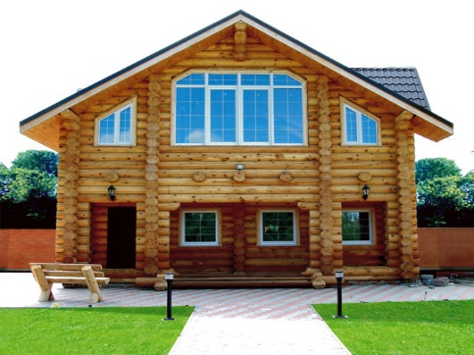


11. Imagine that you’re doing a project “Shopping in the Market” together with your friend. You have found some illustrations and want to share the news. Leave a voice message to your friend. In 2.5 minutes be ready to tell the friend about the photos:
- Give a brief description of the photos (2 features connected with the subject of the project in each photo minimum);
- Say in what way the pictures are different (2 features connected with the subject of the project minimum);
- Mention the advantages and disadvantages (1-2) of the two types of markets;
- Explain how these photos illustrate the project;
- Express your opinion on the subject of the project – whether you would like to buy food in a street market or in a supermarket and why.


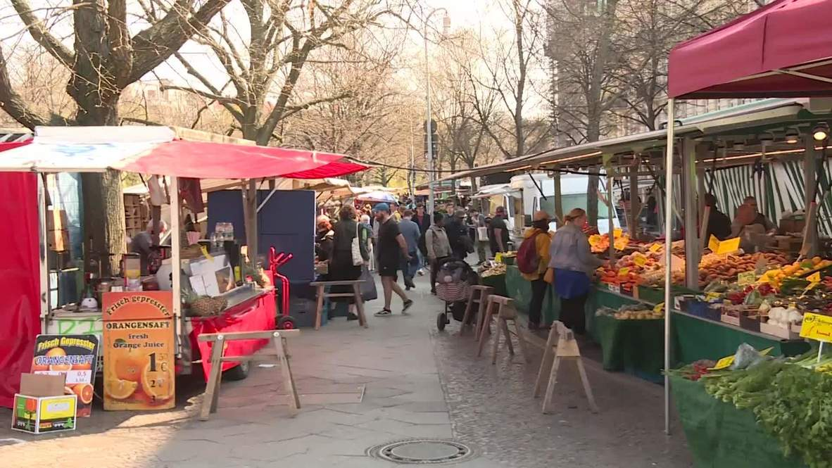

12. Imagine that you’re doing a project “Seasons” together with your friend. You have found some illustrations and want to share the news. Leave a voice message to your friend. In 2.5 minutes be ready to tell the friend about the photos:
- Give a brief description of the photos (2 features connected with the subject of the project in each photo minimum);
- Say in what way the pictures are different (2 features connected with the subject of the project minimum);
- Mention the advantages and disadvantages (1-2) of the two seasons;
- Explain how these photos illustrate the project;
- Express your opinion on the subject of the project – whether you like summer or winter and why.




13. Imagine that you’re doing a project “Types of Holidays” together with your friend. You have found some illustrations and want to share the news. Leave a voice message to your friend. In 2.5 minutes be ready to tell the friend about the photos:

- Give a brief description of the photos (2 features connected with the subject of the project in each photo minimum);
- Say in what way the pictures are different (2 features connected with the subject of the project minimum);
- Mention the advantages and disadvantages (1-2) of the two types of holidays;
- Explain how these photos illustrate the project;
- Express your opinion on the subject of the project – whether you would prefer to go on a cultural holiday or a beach holiday and why.




14. Imagine that you’re doing a project “Sports Games of the World” together with your friend. You have found some illustrations and want to share the news. Leave a voice message to your friend. In 2.5 minutes be ready to tell the friend about the photos:

- Give a brief description of the photos (2 features connected with the subject of the project in each photo minimum);
- Say in what way the pictures are different (2 features connected with the subject of the project minimum);
- Mention the advantages and disadvantages (1-2) of the two types of games;
- Explain how these photos illustrate the project;
- Express your opinion on the subject of the project – whether you would like to play football or golf and why.


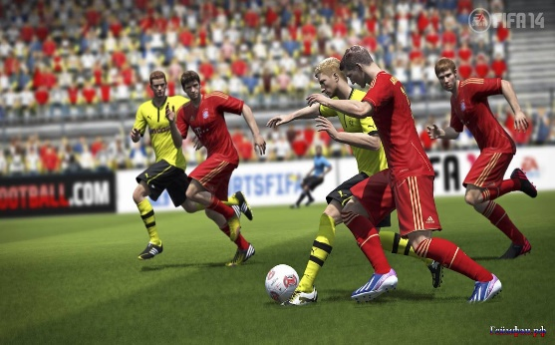

15. Imagine that you’re doing a project “Getting Across the City” together with your friend. You have found some illustrations and want to share the news. Leave a voice message to your friend. In 2.5 minutes be ready to tell the friend about the photos:

- Give a brief description of the photos (2 features connected with the subject of the project in each photo minimum);
- Say in what way the pictures are different (2 features connected with the subject of the project minimum);
- Mention the advantages and disadvantages (1-2) of the two types of transport;
- Explain how these photos illustrate the project;
- Express your opinion on the subject of the project – whether you would like to go across the city by bus or by car and why.


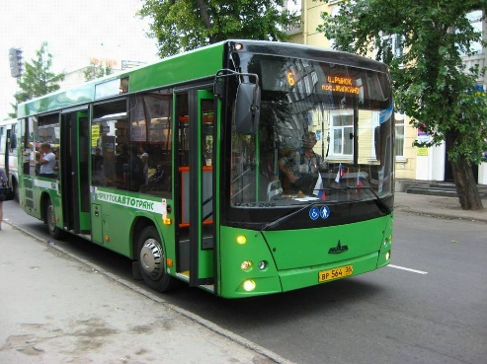

16. Imagine that you’re doing a project “Different Kinds of Music” together with your friend. You have found some illustrations and want to share the news. Leave a voice message to your friend. In 2.5 minutes be ready to tell the friend about the photos:

- Give a brief description of the photos (2 features connected with the subject of the project in each photo minimum);
- Say in what way the pictures are different (2 features connected with the subject of the project minimum);
- Mention the advantages and disadvantages (1-2) of the two types of music;
- Explain how these photos illustrate the project;
- Express your opinion on the subject of the project – whether you would prefer to listen to an orchestra or a band singer and why.




17. Imagine that you’re doing a project “Eating at Home or Eating Out?” together with your friend. You have found some illustrations and want to share the news. Leave a voice message to your friend. In 2.5 minutes be ready to tell the friend about the photos:

- Give a brief description of the photos (2 features connected with the subject of the project in each photo minimum);
- Say in what way the pictures are different (2 features connected with the subject of the project minimum);
- Mention the advantages and disadvantages (1-2) of the two types of eating habits;
- Explain how these photos illustrate the project;
- Express your opinion on the subject of the project – whether you prefer to eat at home or to eat out and why.




18. Imagine that you’re doing a project “Extreme sports” together with your friend. You have found some illustrations and want to share the news. Leave a voice message to your friend. In 2.5 minutes be ready to tell the friend about the photos:

- Give a brief description of the photos (2 features connected with the subject of the project in each photo minimum);
- Say in what way the pictures are different (2 features connected with the subject of the project minimum);
- Mention the advantages and disadvantages (1-2) of the two types of extreme sports;
- Explain how these photos illustrate the project;
- Express your opinion on the subject of the project – whether you would like to take up any type of extreme sports and why.





19. Imagine that you’re doing a project “Cities and Cars” together with your friend. You have found some illustrations and want to share the news. Leave a voice message to your friend. In 2.5 minutes be ready to tell the friend about the photos:

- Give a brief description of the photos (2 features connected with the subject of the project in each photo minimum);
- Say in what way the pictures are different (2 features connected with the subject of the project minimum);
- Mention the advantages and disadvantages (1-2) of banning cars from cities;
- Explain how these photos illustrate the project;
- Express your opinion on the subject of the project – whether you would prefer to live with or without cars in the city and why.

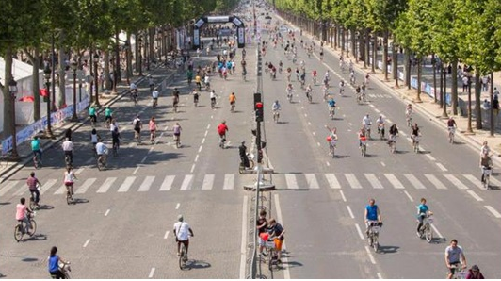



20. Imagine that you’re doing a project “Types of Schools” together with your friend. You have found some illustrations and want to share the news. Leave a voice message to your friend. In 2.5 minutes be ready to tell the friend about the photos:

- Give a brief description of the photos (2 features connected with the subject of the project in each photo minimum);
- Say in what way the pictures are different (2 features connected with the subject of the project minimum);
- Mention the advantages and disadvantages (1-2) of the two types of schools;
- Explain how these photos illustrate the project;
- Express your opinion on the subject of the project – whether you would prefer to study in a single-gender school or in a co-educational mixed school and why.





