ЕГЭ. WRITING AN EMAIL LETTER. NEW
Model. Sample answer.
TASK: You have received an email message from your English speaking pen-friend Steve:
From: Steve@mail.uk
To: Russian friend@ege.ru
Subject: reading habits
… At college, we are doing projects on reading habits of people in different countries. Could you tell me what kind of books you and the members of your family like reading?
As for the family news, my sister got married last week…

Write an e-mail to Steve. In your message:
- Answer your pen-friend’s questions
- Ask 3 questions about his sister’s husband.
Write 100-140 words. Remember the rules of email writing.
REPLY:
From: Kate@mail.ru
To: Steve@mail.uk
Subject: reading habits
Dear Steve,
Thanks a lot for your letter. Sorry, I haven’t answered at once. I was really busy with my study.
In your letter you asked me about reading habits in my family. Well, my father often reads newspapers and magazines. He thinks that it’s the only way to be in the know of everything and my mother’s keen on reading modern novels. However, she wouldn’t mind reading about lives of celebrities.
As for me, I enjoy reading detective stories because they have interesting story lines and unusual endings. I’m particularly captivated by characters who conduct investigations.
By the way, I’m glad your sister got married. What’s her husband’s name? Where’s he from? What does he do?
Actually, I have to stop now as I’ve got loads of homework. Write soon!

All the best,
Ivan

1. You have received an email message from your English speaking pen-friend George:
From: George@mail.uk
To: Russian friend@ege.ru
Subject:
…At school we are doing projects on famous singers from different countries. Could you tell me about any famous Russian singer? What is he or she famous for? How long has he/she been singing? Do you enjoy his/ her songs? Have you ever been to his/her concerts?
As for my school trip to London last week, it was really wonderful…

Write an e-mail to George. In your message:
- Answer your pen-friend’s questions
- Ask 3 questions about his trip to London
Write 100-140 words. Remember the rules of email writing.

2. You have received an email message from your English speaking pen-friend Tina:
From: Tina@mail.uk
To: Russian friend@ege.ru
Subject: movies
…So you see that I enjoy films based on true historic facts whereas most of my friends are fond of soap operas. Do you agree that soaps don’t show life realistically? What kinds of films do you like watching? Do you prefer watching films in the cinema or at home? Why?

Write an e-mail to Tina. In your message:
- Answer your pen-friend’s questions
- Ask 3 questions about her family
Write 100-140 words. Remember the rules of email writing.

3. You have received an email message from your English speaking pen-friend Rob:
From: Rob@mail.uk
To: Russian friend@ege.ru
Subject: technology for school
…and then there’s this chess tournament on Saturday. If I win, I’ll be the champion of our school. Who knows?
Oh, yeah. I wanted to ask you something. We have to write a report on technology for school. Could you tell me a few things about how you use technology in your life? You know, computers, mobiles, TV, that sort of things. Oh, and tell me something about the other members of your family, too, and how they use technology.

Write an e-mail to Rob. In your message:
- Answer your pen-friend’s questions
- Ask 3 questions about playing chess
Write 100-140 words. Remember the rules of email writing.
4. You have received an email message from your English speaking pen-friend Jane:
From: Jane@mail.uk
To: Russian friend@ege.ru
Subject: travelling around Russia in summer
…My home town is rather small but I like it. The people here are very friendly and they try and keep our town clean and beautiful. And do you enjoy living in a big city? How do you spend your spare time there?
Anyway, I’m thinking of travelling around Russia next summer. Could you tell me what weather to expect? Should I take warm clothes with me?

Write an e-mail to Jane. In your message:
- Answer your pen-friend’s questions
- Ask 3 questions about her home town
Write 100-140 words. Remember the rules of email writing.
5. You have received an email message from your English speaking pen-friend Kerstin:
From: Kerstin@mail.uk
To: Russian friend@ege.ru
Subject: English grammar
…I find it a bit difficult to understand English grammar. What about you? Do you do grammar exercises? Do you think that it’s necessary to remember all grammar rules? Have you got any plans for the summer? I was thinking of going to a language school in the UK to improve my English. It would be a lot more fun if we went together. What do you think?
Anyway, I have to go now as I’m helping my Dad in the shop.

Write an e-mail to Kerstin. In your message:
- Answer your pen-friend’s questions
- Ask 3 questions about the trip to the UK
Write 100-140 words. Remember the rules of email writing.
6. You have received an email message from your English speaking pen-friend Adam:
From: Adam @mail.uk
To: Russian friend@ege.ru
Subject: free time activities
…As for me, I’m crazy about skateboarding and I love rock and pop music. I think my favourite band at the moment is Radiohead. Do you know them? What kind of things do you like doing and what music do you enjoy?
Is there anything you particularly want to do while you’re here? I guess we can do something in the evenings and at weekends. Also, let me know if there are any kinds of food you don’t like…

Write an e-mail to Adam. In your message:
- Answer your pen-friend’s questions
- Ask 3 questions about skateboarding.
Write 100-140 words. Remember the rules of email writing.
7. You have received an email message from your English speaking pen-friend Mary:
From: Mary@mail.uk
To: Russian friend@ege.ru
Subject: literature
…In your previous letter you told me that you had joined your School Literature Club. I wonder what you do at your club meetings. Can I help you in any way? As for me, I enjoy reading very much and I would be really interested to know about famous Russian writers. Who is your favourite writer at the moment? Have you got enough time for reading at home?

Write an e-mail to Mary. In your message:
- Answer your pen-friend’s questions
- Ask 3 questions about her reading preferences
Write 100-140 words. Remember the rules of email writing.
8. You have received an email message from your English speaking pen-friend Gloria:
From: Gloria@mail.uk
To: Russian friend@ege.ru
Subject: visiting Moscow
…I’ve always wanted to visit Moscow so it’ll be great to spend a week at your place. Any ideas as to what we might do? Should I bring any special clothes? Do let me know if there is anything I can get you from England?

Write an e-mail to Gloria. In your message:
- Answer your pen-friend’s questions
- Ask 3 questions about her eating habits.
Write 100-140 words. Remember the rules of email writing.
9. You have received an email message from your English speaking pen-friend Patrick:
From: Patrick@mail.uk
To: Russian friend@ege.ru
Subject: computers in our lives
…We are doing a project at school on how computers are changing people’s lives. Please could you tell me how computers are changing things and how people feel about it? Have you got a computer at home? What do you use it for?
As for me, I’m going on holiday with my parents next weekend…

Write an e-mail to Patrick. In your message:
- Answer your pen-friend’s questions
- Ask 3 questions about his holiday
Write 100-140 words. Remember the rules of email writing.
10. You have received an email message from your English speaking pen-friend Paul:
From: Paul@mail.uk
To: Russian friend@ege.ru
Subject: popular sports
…At school we are doing projects on sports popular in different countries. Could you tell me about two kinds of sports that are popular with Russian teenagers? Why are they popular? Do you have enough time for sports?
By the way, I am thinking of joining our school drama club. Is that a good idea?..

Write an e-mail to Paul. In your message:
- Answer your pen-friend’s questions
- Ask 3 questions about his school drama club
Write 100-140 words. Remember the rules of email writing.
11. You have received an email message from your English speaking pen-friend Jessica:
From: Jessica@mail.uk
To: Russian friend@ege.ru
Subject: fashion
…By the way, we are doing a project at college on the fashion industry in different countries. It would be nice if you could tell me what clothes are popular with teenagers in Russia. Do you have any special fashion for teens? What kind of clothes do you prefer?

Write an e-mail to Jessica. In your message:
- Answer your pen-friend’s questions
- Ask 3 questions about her tastes in clothes
Write 100-140 words. Remember the rules of email writing.
12. You have received an email message from your English speaking pen-friend John:
From: John@mail.uk
To: Russian friend@ege.ru
Subject: Moscow’s historical sites and museums
…I’m going to visit Russia in July. I’ve read a lot about Moscow but I’m especially interested in its history. What historical sites and museums would you recommend me to visit? Is museum entrance fee high in Moscow? Are there any weekdays when the entrance is free for students? Do they allow taking pictures inside?
Well, I must finish now because I’ve got an exam tomorrow …

Write an e-mail to John. In your message:
- Answer your pen-friend’s questions
- Ask 3 questions about his exams and his journey to Russia.
Write 100-140 words. Remember the rules of email writing.
13. You have received an email message from your English speaking pen-friend Andrew:
From: Andrew@mail.uk
To: Russian friend@ege.ru
Subject: surprise party
…In your letter you said you were organizing a surprise party for your friend. Was it difficult to organize? Did you decorate the place? What kind of food did you provide? What did your friend say?
I’d love to hear how it went because my parents let me have a big party at home on my birthday but I’ve got to organize everything myself. I’ve never done anything like that before…

Write an e-mail to Andrew. In your message:
- Answer your pen-friend’s questions
- Ask 3 questions about his birthday party
Write 100-140 words. Remember the rules of email writing.
14. You have received an email message from your English speaking pen-friend Donna:
From: Donna@mail.uk
To: Russian friend@ege.ru
Subject: a pet
…Guess what! My parents let me have a pet for my birthday. Isn’t that great? I haven’t decided yet what kind of pet to get. Have you got a pet? What animals do you think make good pets? Is it difficult to look after your pet? Let me know what you think.
Anyway, I’d better go now. I’ve got loads of homework to do tonight (unfortunately!).

Write an e-mail to Donna. In your message:
- Answer your pen-friend’s questions
- Ask 3 questions about her house
Write 100-140 words. Remember the rules of email writing.
15. You have received an email message from your English speaking pen-friend Jackie:
From: Jackie@mail.uk
To: Russian friend@ege.ru
Subject: holidays
…I’m having a busy time at the moment as I have to write lots of Christmas cards to all my friends and relatives. Do you celebrate Christmas in Russia? What holidays are celebrated in your country? What is your favourite holiday? How do you celebrate it?
Well, I’d better go now. I’ve got to help mum with cooking.

Write an e-mail to Jackie. In your message:
- Answer your pen-friend’s questions
- Ask 3 questions about British holidays
Write 100-140 words. Remember the rules of email writing.
16. You have received an email message from your English speaking pen-friend Susie:
From: Susie @mail.uk
To: Russian friend@ege.ru
Subject: eating habits
…We’re doing a project this month at school on eating habits and customs around the world. Will you be able to help me by telling me what the traditional meals are in your country? What do people typically eat and at what time of day? What are your favourite dishes?
As for me, I’m thinking of going on a diet as I feel I’m too fat…

Write an e-mail to Susie. In your message:
- Answer your pen-friend’s questions
- Ask 3 questions about her new diet
Write 100-140 words. Remember the rules of email writing.
17. You have received an email message from your English speaking pen-friend Sheryl:
From: Sheryl@mail.uk
To: Russian friend@ege.ru
Subject: taking up a hobby
…My friend and I are planning to start a new hobby but we haven’t decided yet what hobby to choose. Do you have any hobbies? Do you feel you have enough time for your hobbies? What hobbies are popular with teenagers in Russia? Are there any hobbies you’d like to take up?
As for my school exams, they are almost over and I’m looking forward to my summer break…

Write an e-mail to Sheryl. In your message:
- Answer your pen-friend’s questions
- Ask 3 questions about her plans for the summer
Write 100-140 words. Remember the rules of email writing.
18. You have received an email message from your English speaking pen-friend David:
From: David @mail.uk
To: Russian friend@ege.ru
Subject: volunteering
…At school we are doing projects on volunteering in different countries. You will help me a lot if you could tell me about volunteering in Russia. Is it popular in Russia? What activities can teenagers take part in? How can they help? Have you ever worked as a volunteer? If not, would you like to try?
Anyway, the weather is fine today and I’m going to try my new skis…

Write an e-mail to David. In your message:
- Answer your pen-friend’s questions
- Ask 3 questions about his hobbies
Write 100-140 words. Remember the rules of email writing.
19. You have received an email message from your English speaking pen-friend Sam:
From: Sam@mail.uk
To: Russian friend@ege.ru
Subject: Moscow
…At school we are doing projects on the greatest capitals of the world. I’ve decided to write about Moscow. Could you tell me about your city? What is special about your capital?
As for the family news, my sister got married last week…

Write an e-mail to Sam. In your message:
- Answer your pen-friend’s questions
- Ask 3 questions about his school and classmates
Write 100-140 words. Remember the rules of email writing.
20. You have received an email message from your English speaking pen-friend Jill:
From: Jill@mail.uk
To: Russian friend@ege.ru
Subject: future career
…Have you ever thought what you are going to do in the future? As for me, I really don’t know what career to choose although my parents say it’s time I made a choice. What kind of job would you prefer to do? Have you asked your parents for advice? Would you like to follow in their footsteps?
Anyway, we’ve got some time to think. Let me know what you think about it.

Write an e-mail to Jill. In your message:
- Answer your pen-friend’s questions
- Ask 3 questions about his hobbies and leisure activities
Write 100-140 words. Remember the rules of email writing.

ЕГЭ. WRITING A PROBLEM-SOLVING ESSAY

Model. Sample answer.
Imagine you are doing a project on what kids at the age between 5 and 14 prefer to do in their free time nowadays. You collected some data on the subject (see the diagram below). Comment on the data and give your personal opinion on the subject of the project.

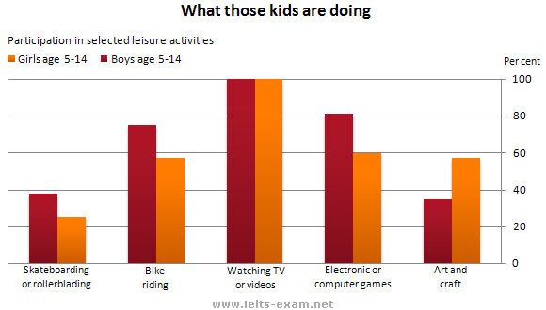
Write 200-250 words. Use the following plan:
- Make an opening statement on the subject of the project;
- Select and report 2-3 main features;
- Make 1-2 comparisons where relevant;
- Outline the problem that can arise with how kids spend their free time and suggest the way of solving it;
- Draw a conclusion giving your personal opinion on the problem.

The graph shows the preferred leisure activities of children aged 5-14. As might be expected, it is clear from the data that sedentary pursuits are far more popular nowadays than active ones.
Of the 10,000 children that were interviewed, all the boys and girls stated that they enjoyed watching TV or videos in their spare time. In addition, the second most popular activity, attracting 80% of boys and 60% of girls, was playing electronic or computer games.
While girls rated activities such as art and craft highly – just under 60% stated that they enjoyed these in their spare time – only 35% of boys opted for creative pastimes. Bike riding, on the other hand, was almost as popular as electronic games amongst boys and, perhaps surprisingly, almost 60% of girls said that they enjoyed this too. Skateboarding was relatively less popular amongst both boys and girls, although it still attracted 35% of boys and 25% of girls.
The diagram reveals the problem of a sedentary lifestyle when active pastimes such as doing sports, going on excursions, walking, playing board games, making handicrafts are being replaced by watching TV or videos. It might happen because it is easy, affordable, comfortable. It requires no skills or efforts. You just switch on TV and watch what you want at any time switching between channels. Having a remote control you even do not need to get up to push the buttons. However, less physical activities lead to many health problems. Therefore, parents must control the amount of time children spend in front of TV-sets. Children can be allowed to watch TV not more than two hours a day.
In conclusion, I cannot but mention that the problem of spending free time among children is still burning because children often do what they want without understanding the consequences and parents must do everything possible to engage their children in other more interesting and useful activities.

- Imagine you’re doing a project on what British teens are going to do soon after leaving High School. You collected some data on the subject (see the table below). Comment on the data and give your personal opinion on the subject of the project.

What British teens are going to do soon after leaving High School
Go travelling | 5%
Do some work | 10%
Go volunteering | 15%
Enter universities | 30%
Don’t know | 40%

Write 200-250 words. Use the following plan:
- Make an opening statement on the subject of the project;
- Select and report 2-3 main features;
- Make 1-2 comparisons where relevant;
- Outline the problem that can arise with making decisions on what to do after leaving school and suggest the way of solving it;
- Draw a conclusion giving your personal opinion on what school-leavers should do soon after school.

- Imagine you’re doing a project on what teens prefer to read in their free time. You collected some data on the subject (see the table below). Comment on the data and give your personal opinion on the subject of the project.

What teens prefer to read in their free time
Historical novels | 5%
Fiction | 10%
Sci-Fi novels | 35%
Fantasy | 38%
Magical Realism | 40%

Write 200-250 words. Use the following plan:
- Make an opening statement on the subject of the project;
- Select and report 2-3 main features;
- Make 1-2 comparisons where relevant;
- Outline the problem that can arise with teens’ favourite literature genres and suggest the way of solving it;
- Draw a conclusion giving your personal opinion on teens’ reading preferences.

- Imagine you’re doing a project on what people use their smartphones for. You collected some data on the subject (see the diagram below). Comment on the data and give your personal opinion on the subject of the project.

Write 200-250 words. Use the following plan:
- Make an opening statement on the subject of the project;
- Select and report 2-3 main features;
- Make 1-2 comparisons where relevant;
- Outline the problem that can arise with using smartphones and suggest the way of solving it;
- Draw a conclusion giving your personal opinion on the role of smartphones in our life.

- Imagine you’re doing a project on what food teens prefer to eat. You collected some data on the subject (see the table below). Comment on the data and give your personal opinion on the subject of the project.
Teens’ eating preferences
Fish | 3%
Porridge | 5 %
Meat | 5 %
Vegetables and fruits | 7 %
Dairy products | 10 %
Sweets, chocolate | 30 %
Chips, cookies, cola | 40 %

Write 200-250 words. Use the following plan:
- Make an opening statement on the subject of the project;
- Select and report 2-3 main features;
- Make 1-2 comparisons where relevant;
- Outline the problem that can arise with teens’ favourite food and suggest the way of solving it;
- Draw a conclusion giving your personal opinion on the role of food in our life.

- Imagine you’re doing a project on what transport commuters prefer to use to get across a big city. You collected some data on the subject (see the diagram below). Comment on the data and give your personal opinion on the subject of the project.

Write 200-250 words. Use the following plan:
- Make an opening statement on the subject of the project;
- Select and report 2-3 main features;
- Make 1-2 comparisons where relevant;
- Outline the problem that can arise with using the transport in a big city and suggest the way of solving it;
- Draw a conclusion giving your personal opinion on the use of transport in the city.

- Imagine you’re doing a project on what children spend their pocket money on. You collected some data on the subject (see the pie-chart below). Comment on the data and give your personal opinion on the subject of the project.

Write 200-250 words. Use the following plan:
- Make an opening statement on the subject of the project;
- Select and report 2-3 main features;
- Make 1-2 comparisons where relevant;
- Outline the problem that can arise with using pocket money by children and suggest the way of solving it;
- Draw a conclusion giving your personal opinion on managing the pocket money.

- Imagine you’re doing a project on what films teens prefer to watch in their free time. You collected some data on the subject (see the diagram below). Comment on the data and give your personal opinion on the subject of the project.

Write 200-250 words. Use the following plan:
- Make an opening statement on the subject of the project;
- Select and report 2-3 main features;
- Make 1-2 comparisons where relevant;
- Outline the problem that can arise with what films teens prefer to watch and suggest the way of solving it;
- Draw a conclusion giving your personal opinion on watching films.

- Imagine you’re doing a project on what kind of music people used to listen to in the 20th century. You collected some data on the subject (see the table below). Comment on the data and give your personal opinion on the subject of the project.
Kind of music people used to listen to in the 20th century
Types of Music | Early 20th century | Late 20th century
Classical music | 30% | 10%
Folk music | 40% | 20%
Jazz music | 40% | 25%
Rock music | 10% | 35%
Pop music | 30% | 40%

Write 200-250 words. Use the following plan:
- Make an opening statement on the subject of the project;
- Select and report 2-3 main features;
- Make 1-2 comparisons where relevant;
- Outline the problem that can arise on what kind of music people used to listen to in the 20th century and suggest the way of solving it;
- Draw a conclusion giving your personal opinion on the role of music in human life.
- Imagine you’re doing a project on factors that can reduce life expectancy of the population in the future. You collected some data on the subject (see the pie-chart below). Comment on the data and give your personal opinion on the subject of the project.

Write 200-250 words. Use the following plan:
- Make an opening statement on the subject of the project;
- Select and report 2-3 main features;
- Make 1-2 comparisons where relevant;
- Outline the problem that can arise on what can reduce life expectancy of the population in the future and suggest the way of solving it;
- Draw a conclusion giving your personal opinion on how to prolong life expectancy.

- Imagine you’re doing a project on how much water people use daily. You collected some data on the subject (see the pie-chart below). Comment on the data and give your personal opinion on the subject of the project.

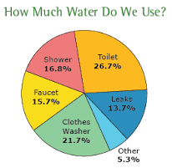
Write 200-250 words. Use the following plan:
- Make an opening statement on the subject of the project;
- Select and report 2-3 main features;
- Make 1-2 comparisons where relevant;
- Outline the problem that can arise with using water and suggest the way of solving it;
- Draw a conclusion giving your personal opinion on the water usage in our life.
- Imagine you’re doing a project on what pets British people like to keep at home. You collected some data on the subject (see the pie-chart below). Comment on the data and give your personal opinion on the subject of the project.
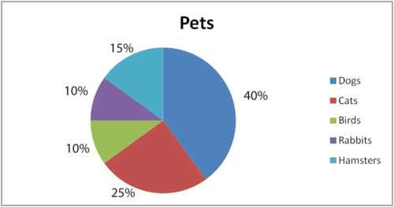
Write 200-250 words. Use the following plan:
- Make an opening statement on the subject of the project;
- Select and report 2-3 main features;
- Make 1-2 comparisons where relevant;
- Outline the problem that can arise with keeping pets and suggest the way of solving it;
- Draw a conclusion giving your personal opinion on the role of pets in our life.

- Imagine you’re doing a project on rates of smoking people in Russia. You collected some data on the subject (see the graph below). Comment on the data and give your personal opinion on the subject of the project.
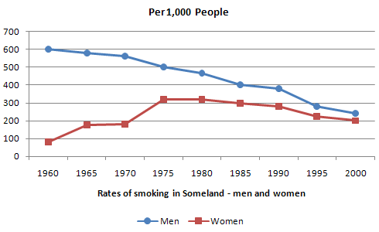

1950 1960 1970 1980 1990 2000 2010 2020
Write 200-250 words. Use the following plan:
- Make an opening statement on the subject of the project;
- Select and report 2-3 main features;
- Make 1-2 comparisons where relevant;
- Outline the problem that can arise with smoking and suggest the way of solving it;
- Draw a conclusion giving your personal opinion on smoking.

- Imagine you’re doing a project on rates of committing crimes in Britain within last year. You collected some data on the subject (see the graph below). Comment on the data and give your personal opinion on the subject of the project.
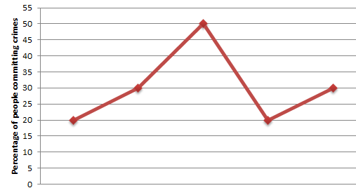
January April July October December
Write 200-250 words. Use the following plan:
- Make an opening statement on the subject of the project;
- Select and report 2-3 main features;
- Make 1-2 comparisons where relevant;
- Outline the problem that can arise with such crime rates and suggest the way of solving it;
- Draw a conclusion giving your personal opinion on the problem.

- Imagine you’re doing a project on what technologies people use more often. You collected some data on the subject (see the diagram below). Comment on the data and give your personal opinion on the subject of the project.
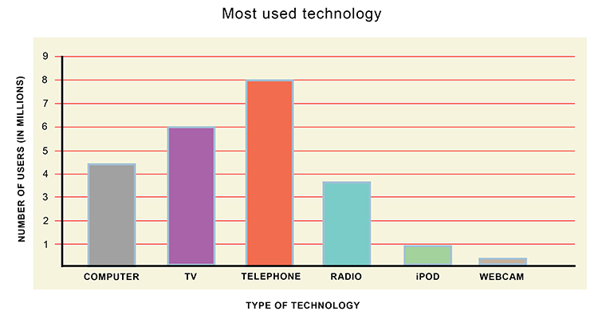
Write 200-250 words. Use the following plan:
- Make an opening statement on the subject of the project;
- Select and report 2-3 main features;
- Make 1-2 comparisons where relevant;
- Outline the problem that can arise with the use of new technologies and suggest the way of solving it;
- Draw a conclusion giving your personal opinion on the role of new technologies in our life.

- Imagine you are doing a project on the problem of deforestation in the world. You collected some data on the subject (see the diagram below). Comment on the data and give your personal opinion on the subject of the project.
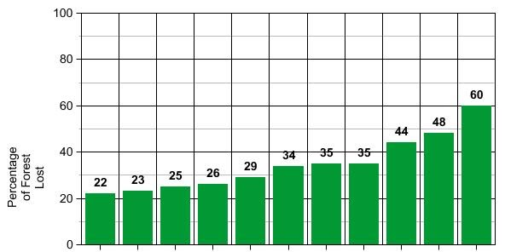
Write 200-250 words. Use the following plan:
- Make an opening statement on the subject of the project;
- Select and report 2-3 main features;
- Make 1-2 comparisons where relevant;
- Outline the problem that can arise with deforestation and suggest the way of solving it;
- Draw a conclusion giving your personal opinion on the role of forests in the world.

- Imagine you’re doing a project on number of marriages and divorces in America. You collected some data on the subject (see the bar chart below). Comment on the data and give your personal opinion on the subject of the project.
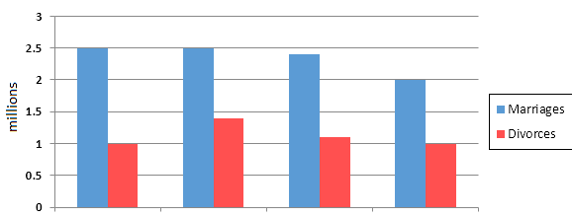
2000 2010 2015 2020
Write 200-250 words. Use the following plan:
- Make an opening statement on the subject of the project;
- Select and report 2-3 main features;
- Make 1-2 comparisons where relevant;
- Outline the problem that can arise in the society and suggest the way of solving it;
- Draw a conclusion giving your personal opinion on the problem.

- Imagine you’re doing a project to find out what people mostly spend their money on. You collected some data on the subject (see the table/chart/graph/diagram below). Comment on the data and give your personal opinion on the subject of the project.

Write 200-250 words. Use the following plan:
- Make an opening statement on the subject of the project;
- Select and report 2-3 main features;
- Make 1-2 comparisons where relevant;
- Outline the problem that can arise with spending the money and suggest the way of solving it;
- Draw a conclusion giving your personal opinion on the problem.

- Imagine you’re doing a project on categories of families living in poverty in America in 2020. You collected some data on the subject (see the table below). Comment on the data and give your personal opinion on the subject of the project.

Types of families living in poverty in America in 2020
Family type | Proportion of people from each  household type living in poverty
aged couple  aged person  couple, no children  single, no children couple with children  sole parent | 4% (48,000)  6% (54,000)  7% (211,000)  12% (933,000)  19% (359,000)  23% (232,000)

Write 200-250 words. Use the following plan:
- Make an opening statement on the subject of the project;
- Select and report 2-3 main features;
- Make 1-2 comparisons where relevant;
- Outline the problem that can arise in the American society and suggest the way of solving it;
- Draw a conclusion giving your personal opinion on the problem of poverty.

- Imagine you’re doing a project on the most frequent diseases people suffer from in European countries nowadays. You collected some data on the subject (see the pie-chart below). Comment on the data and give your personal opinion on the subject of the project.
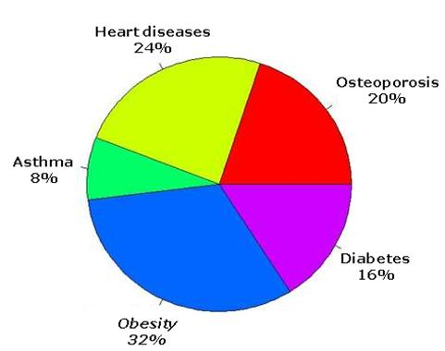
Write 200-250 words. Use the following plan:
- Make an opening statement on the subject of the project;
- Select and report 2-3 main features;
- Make 1-2 comparisons where relevant;
- Outline the problem that can arise in the society and suggest the way of solving it;
- Draw a conclusion giving your personal opinion on the problem.

- Imagine you are doing a project on education level of men and women in India. You collected some data on the subject (see the diagram below). Comment on the data and give your personal opinion on the subject of the project.
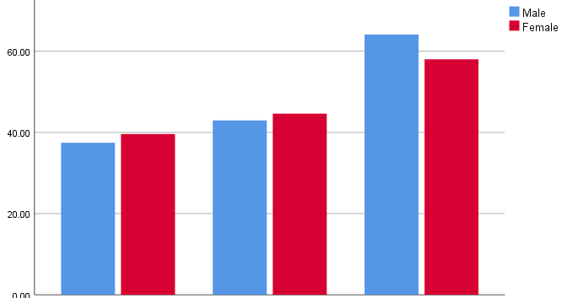

University education college education school education

Write 200-250 words. Use the following plan:
- Make an opening statement on the subject of the project;
- Select and report 2-3 main features;
- Make 1-2 comparisons where relevant;
- Outline the problem that can arise with such an education level and suggest the way of solving it;
- Draw a conclusion giving your personal opinion on the problem.

